# Python Setup for Mac

**Please complete the setup before the class (Jan 25 2022)**

## Install Miniconda

Download miniconda installation from <https://docs.conda.io/en/latest/miniconda.html>

Open a terminal and follow the installation instructions

<https://docs.conda.io/projects/conda/en/latest/user-guide/install/macos.html#installing-on-macos>

Once you have completed the installation, close the terminal and open a new terminal. You should see ‘(base)’ in your command prompt. You can now proceed to the next section.

## Virtual Environment Setup

Conda allow you to partition your application into different environment; this is to ensure that Python applications do not ‘interfere’ with each other; eg. applications using different versions of the same library

On your Mac open a terminal.

Create a new environment

conda create --name myenv

where myenv is the name of your environment. Feel free to use any name. You can create multiple environment

Note: You can confirm the newly created environment, by listing all envs

conda env list

Activate your environment

Once you have created your environment, you will need to activate it

conda activate myenv

Your command prompt will now include the environment’s name.

Exit from your environment

To exit from your Conda environment type the following command

conda deactivate

## Installing packages into your environment

You will now need to install Python packages into your environment. **Before installation, activate your environment; this step is important!**.

These are the list of packages will will be installing into the environment

* numpy
* matplotlib
* tqdm
* gym
* pyglet

On your terminal, type the following command (activate your environment before installing these packages)

conda install numpy matplotlib tqdm pip

pip install gym pyglet

Follow the installation instructions.

## Install Visual Studio Code

Download and install Visual Studio Code (VSC); see instructions from the following page

<https://code.visualstudio.com/docs/setup/mac>

After you have installed VSC, launch it. Next, we need to install the Python Extension for VSC. Open the extension panel by clicking on this icon  on the menu along VSC’s left window edge. Type Python on the extension window and select the Microsoft Python Extension. See the following image

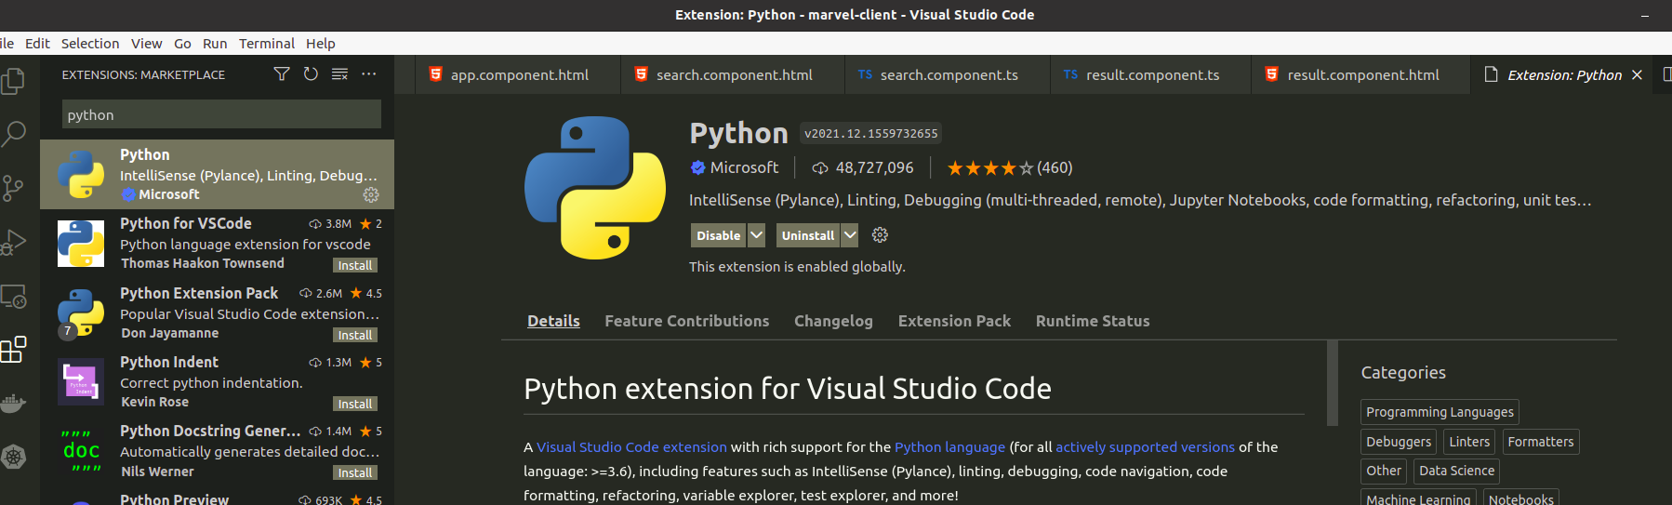

Click on Install to install the extension. After installing the extension, restart VSC. See [Visual Studio Code and the Python Extension](https://code.visualstudio.com/docs/python/python-tutorial#_install-visual-studio-code-and-the-python-extension);

If you like to try out VSC, see following

<https://code.visualstudio.com/docs/python/python-tutorial>

## Slack Channel

I have set up a Slack channel for this workshop. You can use this channel to ask questions. I will also be using this channel to post materials and references. You can use your school or private email to join

<https://join.slack.com/t/sst-2022/shared_invite/zt-121qnjzb4-wqgnE5DbWvpkJf8qbyTbHQ>

Joining the channel is optional.

## Further Reading

For more information on Conda, see the following documents on working with Conda

* [Getting started with Conda](https://docs.conda.io/projects/conda/en/latest/user-guide/getting-started.html#getting-started-with-conda)
* [Virtual Environments](https://problemsolvingwithpython.com/99-Appendix/99.03-Virtual-Environments/)